How to use this email template
The template begins on page 2 of this document. To copy this template into your email software:
- Review the email to insert your logo. Click on the photo icon in the logo placeholder image. An Insert window will come up. Choose From a File to upload your logo from a saved copy on your computer. Once the logo is uploaded, remove the red text.
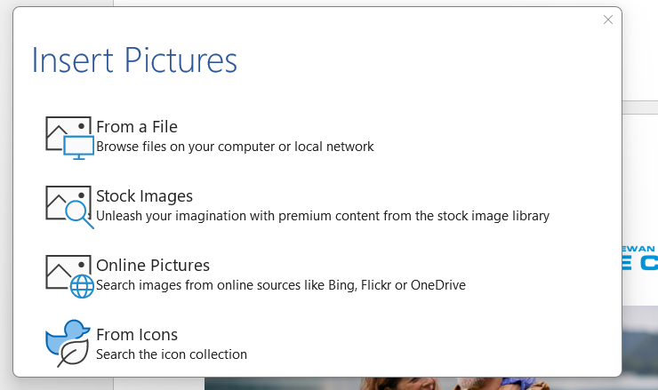
- Read through the email to insert your broker or brokerage name wherever needed.
- IMPORTANT: Ensure you update your contact information in the blue section at the bottom of the email.
TO PREPARE THE EMAIL TO SEND
- Hover over the upper left corner of the template, near the Saskatchewan Blue Cross logo. A small + will appear.
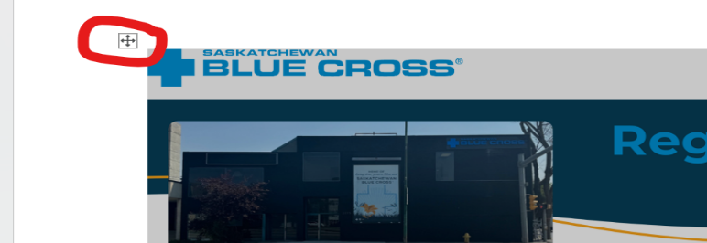
- Click on the + to select the template table. Then, right click on the + button and select Copy.
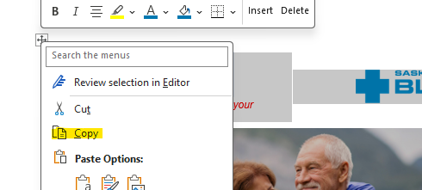
- Open a new email in Outlook. In the Ribbon, at the left of the email message window, click the dropdown below the Paste button (highlighted below).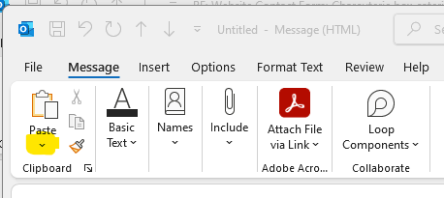
- Select the second option on the dropdown menu, called Keep Source Formatting. 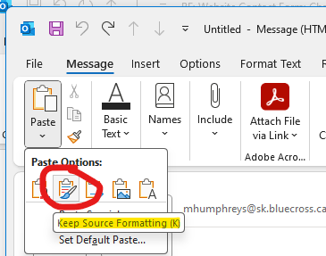
- The template will then be pasted into the body of the email.
- Your email is ready to send.

  [click on the photo icon above to insert your brokerage logo, then remove this text] |  | 

Health insurance could help you maintain your health.
As your personal insurance advisor, let me show you how.
Health insurance is more than “in case of emergency.” A personal health insurance plan is full of wellness benefits, like coverage for massage therapy and chiropractor visits, vision care and hearing aids.

As your trusted insurance advisor, I believe your health insurance needs are as unique as you are.
Saskatchewan Blue Cross offers personal health insurance that’s customizable to meet your needs. You’ll feel confident knowing you and your family are protected against unexpected medical expenses.

Choose from three available plan designs:

BLUE CHOICE®  Designed with customization in mind, Blue Choice is perfect for individuals, couples and families alike.  This plan requires you to complete a medical questionnaire as part of your application. | CONVERSION  Perfect for those retiring or changing jobs, the Conversion plan allows you to convert your benefits, so you won’t experience a gap in coverage.  This plan does not require a medical questionnaire. You must apply within 60 days of leaving your group benefits plan. |  | GUARANTEED ACCEPTANCE  The most comprehensive benefits package, the Guaranteed Acceptance plan offers health insurance to everyone, guaranteed.  No medical questionnaire required, no waiting periods – you’re covered.
Explore what each plan covers here.

 | Getting coverage is easy!  Step 1: Choose core coverage.  We’ll walk you through available plan options to help you decide on the best fit for your needs.  Step 2: Customize your plan and get a quote.  Maybe you need dental coverage or want to travel freely with VIP Travel. We’ll help you choose the right optional coverage.  Step 3: Submit your application.  Together we can complete your application. It’s easy to complete and can be finished in minutes! Reach out to me today to discuss your options and customize your personal health insurance plan.
Ready for the next step?
Give us a call at [broker phone number] or reply to this email to get started.
Have questions or need more information?
We’re here to help.

[Broker name] at [Brokerage]
[Phone Number] • [Email address]
[Brokerage address]
______________________________________

This message was sent in partnership with Saskatchewan Blue Cross.


®* The Blue Cross symbol and name are registered marks of the Canadian Association of Blue Cross Plans, an association of independent Blue Cross plans, used under licence by Medical Services Incorporated an independent licensee. *Trade-mark of the Canadian Association of Blue Cross Plans. †Trade-mark of the Blue Cross Blue Shield Association. Saskatchewan Blue Cross products are underwritten by a variety of underwriters. For more information, visit sk.bluecross.ca/underwriting.

